ALL ANSWERS MUS? BE IN COWVIPLETE SENTENCES UNLESS OTHERWISE STATED.

29 How cid the author first know thai the wails of the young child were very loud? [tm]

LL LL A A

LL LL LL pa yp

30 =What had caused the young child to cry? [1mm]

Oe ——————___—L_ LL A N ees lligyy-—=e ssh

ot Why did the author need the young child to be still? (line $) [4m]

ES $y Ay lS ceded —~eeeeeee—e~vieedl-e_ ssc see sp

7 ee 3 py linens wets.

32 Look at the table below. Whai do tne words in the left colurnn rejer to in the passage?  
Write your answers in the column in the right. (2m)

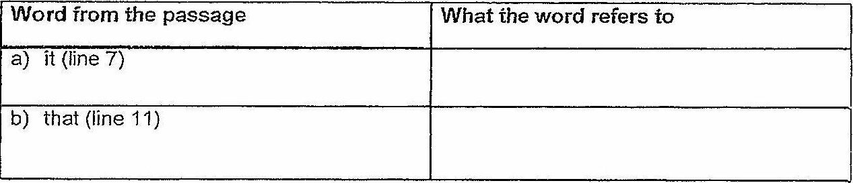

35 Fil} in the following table by identifying the correct word(s) from the passage. [3rn]

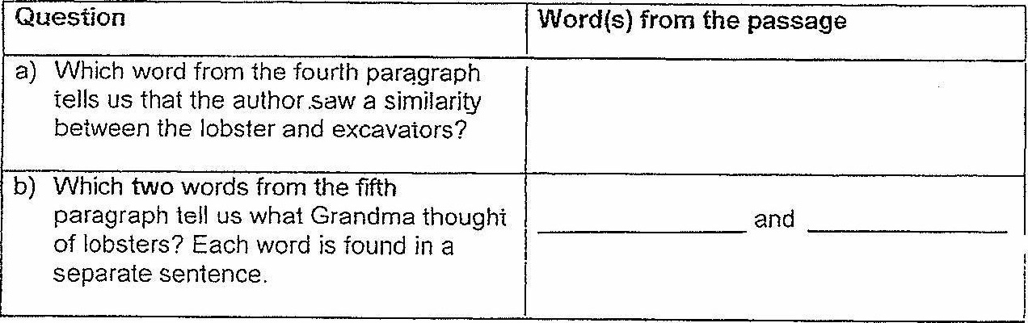

(lo GF i ime NEXt Pee}